
Smarter Diabetes Management

ALR Technologies (ALRT) has developed and completed validation testing on a first of its kind FDA-cleared, HIPAA-compliant software that solves the costly, systemic patient self-management and adherence to care plan problems for the global diabetes population. We are in the process of acquiring a new and revolutionary low-cost Continuous Glucose Monitor (CGM) to pair with our software. Our bundled offering will compete in price with the Blood Glucose Monitor (BGM) market to serve the world’s 537 million diabetics. The incumbents in the CGM space, Abbott and Dexcom, have created a premium priced diabetes monitoring category by making CGMs very expensive and pairing their technology with software reliant on patient self-management. While our CGM technology will operate on a comparable basis, we will pair it with our superior software platform utilizing active patient management and will sell the bundled offering at a cost equivalent to existing BGM products.

In the meantime, we are executing on an immediate opportunity in animal health by launching the world’s first and only CGM for diabetic cats and dogs called the GluCurve Pet CGM. Seeing a market void and recognizing a faster path to market, we adapted our diabetes solution software for humans to meet the specific needs of veterinarians and created the only diabetes patient management platform and CGM to serve the millions of diabetic pets globally. We have partnered with Covetrus, one of the largest animal health companies in the world to market and sell directly to veterinary clinics. The GluCurve Pet CGM will be featured in January 2023 at the Consumer Electronics Show (CES) in Las Vegas.

The animal health initiative is highly profitable and will fund the expansion into the human market with the low-cost CGM.

The Problem

Diabetes is among the top drivers of healthcare costs, morbidity, and mortality. Why? Two words, Clinical Inertia - failure to advance therapy on a timely basis. Addressing clinical inertia is essential in diabetes management and maintaining glycemic control to prevent an array of severe complications, such as heart and kidney disease, lower limb amputations, and death.
Blood glucose test data is invaluable information in effectively managing diabetes, but instead of healthcare professionals collecting, processing, analyzing, and acting on that data, currently, patients are asked to self-manage.

At ALRT, we believe this to be the fundamental flaw in diabetes care. It has been well documented that self-management is not effective. Gaps in diabetes self-management are underscored by socio-demographic, behavioral, psychological, and cultural barriers.

Software: The ALRT Diabetes Solution

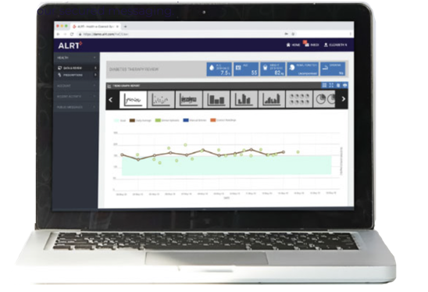
ALRT has solved this problem by creating a diabetes management solution app that collects and processes blood glucose data directly from the patient’s CGM using Bluetooth. The data is sent securely to the provider’s portal where the data is managed using artificial intelligence (AI). The secure system is programmed to continuously analyze patient glucose data looking for irregularities that warrant intervention, notifying the care team upon discovery.

The patient can still self-manage their diabetes utilizing the wealth of useful data on the ALRT app, but the provider is alerted if the patient is not adhering to their care plan or needs to advance therapy.

The ALRT system allows healthcare providers to advance diabetes care in a timely manner based on
specific patient needs and best practice guidelines. Essentially, the ALRT Diabetes Solution assists healthcare providers in overcoming the hurdles that cause Clinical Inertia.

Clinical trials and pilot studies of the ALRT system have shown a 1.2% reduction of A1C over just 6 months. A1C is a common blood glucose test and gold standard used in diabetes and prediabetes diagnoses that measures average levels of blood sugar over the past three months. A 1.2% reduction can meaningfully translate to improved outcomes and lower costs, as measured by ADA (American Diabetes Association) and UKPDS (UK Prospective Diabetes Study) data showing that a 1% drop in A1C reduces cardiovascular risks by 45%, microvascular disease by 25%, and death by 21%.

Hardware: Low-Cost Continuous Glucose Monitoring

CGMs work by inserting an electrode covered in enzymes into the interstitial fluid just under the skin. The enzymes interact with glucose to create minute amounts of electricity that is recorded and translated into blood sugar levels.

The core of a CGM and its secret sauce are how the enzymes are fixed onto the electrode and the manufacturing process to ensure stability and a high yield rate. Abbott prints the enzymes onto the electrode and Dexcom (and Infinovo, ALRT’s animal health CGM manufacturer) layers them.

We are working to acquire a new cutting-edge approach that will produce CGMs at less than half the cost of Abbott’s manufacturer.

Animal Health: The GluCurve Pet CGM
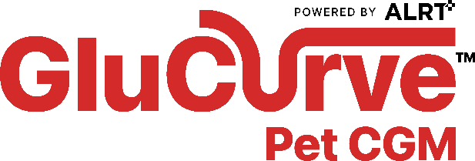
Currently, diabetic cats and dogs are monitored for diabetes by dropping the pet off at a veterinary clinic for 10-12 hours so blood can be drawn approximately every two hours with a syringe to test in a BGM. At the end of the day, a glucose curve graph is manually created for the 6-7 readings.

Being away from its owner in a veterinary clinic all day and getting repeatedly stuck by a needle causes high levels of stress in the animal, which results in elevated and inaccurate blood sugar readings. This entire process is labor and time intensive for the veterinarian and staff which makes it financially unfavorable. The limited number of readings and being in a clinical setting does not accurately depict the pet’s daily home life. Safe to say, the status quo is sub-optimal at best for the pet, owner, vet, and staff.

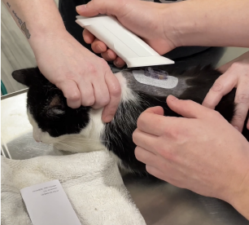
These factors have left veterinarians desperate for another way to monitor diabetes. Many have started using a human CGM off label, which is very problematic, but better than aforementioned standard of care. Not only does it require a prescription and a trip to the pharmacy, but the human CGM company will not support animal health because it is not designed for animals so there are no instructions, customer service, or features for pets.

The GluCurve Pet CGM is sold directly to veterinarians so they can have it on hand to use when needed, and upcharge to profit off their time. It is designed specifically for animals and solves the many shortcomings of using a human CGM off label.

We at ALRT received tremendous interest on the GluCurve Pet CGM from major pharmaceutical companies and the global distributors in animal health. After careful consideration we decided to partner with Covetrus for distribution in the US and EU due to their global reach, dedication to animal health, and experience with technology. Furthermore, we are seeking collaborations with the pharmaceutical companies who manufacture animal insulins to leverage our proprietary, FDA-cleared, AI-based insulin dosing adjustment technology (originally developed for human use) to explore the opportunity to introduce an insulin dose suggestion feature to our veterinary platform.

Get in touch with us at media@ALRT.com

